Technical Design for World Builder Meta Data

(Locators / Trigger Volumes)

Revision History

Issue | Date | Person | Reason
0.1 | April 04, 2002 | Cary Brisebois | Creation
1.0 | April 12, 2002 | Cary Brisebois | Reviewed by team and released

Description

Introduction
The creation of the game requires meta-data that the designers define and the AI uses. The data is broken into locator and trigger volumes. Locators are points in space that hold information. Trigger volumes are regions of space that can be used to detect when something is colliding/penetrating it. A trigger volume always has a reference to a locator but the reverse is not required. Generally, when a trigger volume is triggered, a locator is activated and its data is accessed.

This data is laid out using the Maya “World Builder” plug-in. This plug-in is essentially the same as last year, but this year the locator and trigger volume requirements are simpler.

This document will describe both the world builder aspect of locators and trigger volumes and the runtime aspect.

Requirements
Trigger Volumes:
- Have a locator that stores the information that the game needs to know;
- Encapsulate a volume of space which when entered makes the locator’s data available to the game; and
- Can be either rectangular (3D) or spherical.
- Can be tested to see if you’ve entered, exited or are inside of it.

Locators:
- Have a position in space;
- Have a name that the AI can reference;
- Have data that the AI can use; and
- Have a type specifier (position, event, script)

References
- Talked to Joe about the meta-data needs vs what we had last year.
- Talked to Darren about the sound requirements.
- Talked to Darwin about scripting.
- Greg about using the physics collision system.

Technical Design

World Builder

2.1.1 Overview
As was done for SRR 1, the world builder (WB) needs an interface to place the meta-data required for the game. This year we will re-use the interface from SRR1 since the designers are used to it and it was easy to extend. We will reduce the scope of the interface since the requirements of meta-data have been simplified.

For SRR 2 we only need to place three types of locators: Position locators, Event locators, and Script Locators. The difference between these locators is that event and script locators require a trigger volume where position locators are used to place things in the world that are referenced by scripts and the AI. The WB interface will allow the placement of the three types with drop-down lists of available events or scripts as required. Since additions to the interface are likely, it is kept simple.

Example position locators are:
- Character locations
- Special vehicle positions
- Special item positions

Example event locators are:
- Sounds
- Explosion effects
- Waypoints

Example script locators are:
- Door triggers
- Presentations
- Missions

2.1.2 Interface
The world builder (WB) plug-in supplies the user with a window that offers locator and trigger volume creation.

Sound Locator
Sound Trigger Volume

Event Locator
Position Locator

Example of each type of locator placed in the world.

2.1.3 Export
All the locators will be exported into files for processing by the pipeline. SRR 2 will use the P3D format for processing locators and trigger volumes. One advantage over SRR 1 is that locators will no longer use strings for data; for SRR2 only numeric values will be used since all the event and script names can be hashed into numeric values.

Locators and Trigger Volumes in the Run-time

2.2.1 Overview
The locators and trigger volumes will have a very lightweight profile for SRR 2 compared to SRR 1. In SRR 1 all locators carried data in string format. This will not be the case in SRR 2.

The locators and trigger volumes system is broken into the following classes:
- Locators
- Trigger Volumes
- Trigger Volume Tracker

Each simulation frame, the Trigger Volume tracker tests all the trigger volumes around the player within a given radius. If any of the triggers collide with the player, either the event is signalled or the script is called depending on the type of locator the trigger is connected to. It is possible that AI avatars will use the trigger volume tracker to deteck when they collide with trigger volumes.

Position locators never actively do anything. It is up to the AI or a given script to access the locators.

This system is essentially the same as SRR 1, so it is not high risk.

For SRR 1 the collision detection of the trigger volumes and the car was done using a system separate from the physics collision system. It used simple point-sphere, line-sphere, point-box and line-box intersection tests. This year it may be possible to use the physics collision system instead of its own collision detection system. This is TBD.

2.2.2 Locators
class Locator
{
public:
enum Flag
{
ACTIVE,
DRAWN,
USED
};

enum DataType
{
EVENT,
SCRIPT,
INVALID
};

Locator();
virtual ~Locator();

void SetLocation( const rmt::Vector& loc );
void GetLocation( rmt::Vector* loc ) const;

void SetID( unsigned int id );
unsigned int GetID() const;

void SetData( unsigned int data );
unsigned int GetData() const;

void SetDataType( DataType type );
DataType GetDataType() const;

void SetFlag( Flag flag, bool on );
bool GetFlag( Flag flag ) const ;

virtual void SetTriggerVolume( TriggerVolume* volume );
virtual TriggerVolume* GetTriggerVolume();

private:
unsigned int mID;
unsigned int mData;
DataType mDataType;
unsigned int mFlags;

rmt::Vector mLocation;
};

class TriggerLocator : public Locator
{
public:
TriggerLocator();
virtual ~TriggerLocator();

virtual void SetTriggerVolume( TriggerVolume* volume );
virtual TriggerVolume* GetTriggerVolume();

private:
TriggerVolume* mTriggerVolume;
};

2.2.3 Trigger Volumes
class TriggerVolume : public tEntity
{
public:
enum Type
{
SPHERE,
RECTANGLE
};

TriggerVolume();
virtual ~TriggerVolume();

//Intersect tests
virtual bool Contains( const rmt::Vector& point,
float epsilon = 0.0f ) const = 0;
virtual bool IntersectsBox( const rmt::Vector& p1,
const rmt::Vector& p2,
const rmt::Vector& p3,
const rmt::Vector& p4 ) const = 0;

virtual bool GetBoundingBox() const = 0;
virtual Type GetType() const = 0;

TriggerLocator* GetLocator();
void SetLocator( TriggerLocator* locator );

void SetFrameUsed( unsigned int frame, int user );
int GetFrameUsed() const;
int GetUser() const;

bool IsActive();

private:
TriggerLocator* mLocator;

unsigned int mFrameUsed;
int mUser;
};

class SphereTriggerVolume : public TriggerVolume
{
public:
SphereTriggerVolume();
SphereTriggerVolume( const rmt::Vector& centre, float radius );
virtual ~SphereTriggerVolume();

// Intersection information
bool Contains( const rmt::Vector& point, float epsilon = 0.00f ) const;

// Intersection of bounding box with trigger volume.
//p1 - p4 are the four corners of the box.
bool IntersectsBox( const rmt::Vector& p1,
const rmt::Vector& p2,
const rmt::Vector& p3,
const rmt::Vector& p4 ) const;

// Bounding box
bool GetBoundingBox( rmt::Vector& p1, rmt::Vector& p2 ) const;

const rmt::Vector& GetSphereCentre() const;
void SetSphereCentre( const rmt::Vector& centre );
float GetSphereRadius() const;
void SetSphereRadius( float radius );

virtual Type GetType() const;

private:
bool IntersectLineSphere( const rmt::Vector& lineOrig,
const rmt::Vector& lineDir ) const;

// For sphere type
rmt::Vector mCentre;
float mRadius;
};

class RectTriggerVolume : public TriggerVolume
{
public:
RectTriggerVolume();
RectTriggerVolume( const rmt::Vector& center,
const rmt::Vector& axisX,
const rmt::Vector& axisY,
const rmt::Vector& axisZ,
float extentX,
float extentY,
float extentZ );
virtual ~RectTriggerVolume();

// Intersection information
bool Contains ( const rmt::Vector& point, float epsilon = 0.00f ) const;

// Intersection of bounding box with trigger volume.
//p1 - p4 are the four corners of the box.
bool IntersectsBox( const rmt::Vector& p1,
const rmt::Vector& p2,
const rmt::Vector& p3,
const rmt::Vector& p4 ) const;

// Bounding box
bool GetBoundingBox ( rmt::Vector& p1, rmt::Vector& p2 ) const;

Type GetType() const;

const rmt::Vector& GetCenter() const;
void SetCenter( rmt::Vector center );

const rmt::Vector& GetAxisX() const;
const rmt::Vector& GetAxisY() const;
const rmt::Vector& GetAxisZ() const;

float GetExtentX() const;
void SetExtentX( float extent );

float GetExtentY() const;
void SetExtentY( float extent );

float GetExtentZ() const;
void SetExtentZ( float extent );

const rmt::Matrix& GetW2T();
const rmt::Matrix& GetT2W();

private:
bool IntersectLineRect( const rmt::Vector& lineOrig,
const rmt::Vector& lineDir ) const;

void UpdateW2T();

rmt::Vector mCenter;

rmt::Vector mAxisX;
rmt::Vector mAxisY;
rmt::Vector mAxisZ;

float mExtentX;
float mExtentY;
float mExtentZ;

rmt::Matrix mWorld2Trigger;
rmt::Matrix mTrigger2World;
};

2.2.4 Trigger Volume Tracker
class TriggerVolumeTracker
{
public:
struct TriggerCheck
{
TriggerVolume* volume;
bool active;
};

TriggerVolumeTracker();
virtual ~TriggerVolumeTracker();

void Init( unsigned int playerID );
void UpdatePlayerInfo();
void UpdateTriggers();

unsigned int GetNumVolumes() const;
TriggerVolume* GetVolume( unsigned int which );

void AddTrigger( TriggerVolume* volume,
TriggerCallBack callBack = NULL,
void* data = NULL);
bool IsTriggered( TriggerVolume* volume ) const;
void RemoveTrigger( TriggerVolume* volume );

private:
enum
{
MAX_VOLUMES = 10,
RADIUS = 10
};

bool AddVolToArray( TriggerVolume* vol, TriggerCheck array[MAX_VOLUMES] );
void AddTriggerVolume( TriggerVolume* vol );
unsigned int GetPlayerID() const;

void ShiftVolumesDown( unsigned int i );

TriggerVolume* mVolumes[MAX_VOLUMES];
unsigned int mNumActiveVolumes;
unsigned int mPlayerID;
};

2.2.5 Component Class Diagram
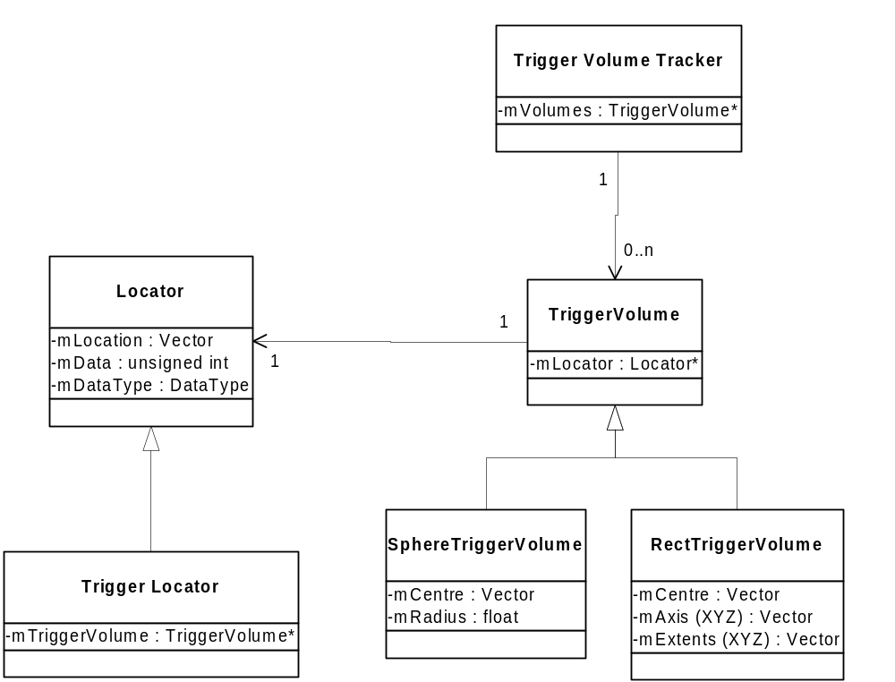

2.2.6 Use Cases

